Michigan Federation of Music Clubs
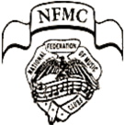
Michigan Federation of Music Clubs is affiliated with National Federation of Music Clubs

Counter Point
Volume 69, Issue 2………………………………………….…………………..………………………………………………………………Fall, 2019
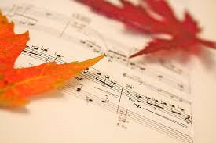
In this issue…
Page 1 | President’s Message
Page 2 | NewsFlash
Page 3 | Fall District Meetings
Page 4 | Poetry Corner
Page 5 | Convention Advertising
Page 6 | In Memoriam: Frances Isaacs  Mary Lou Lourim

Page 1………………………………………………………………………………………………………………………………………………….Fall, 2019

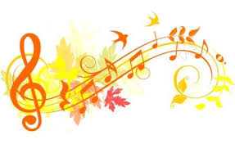

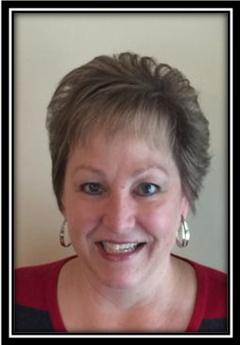
President’s Message

Beatrice Wassenberg
MFMC President

Dear Michigan Federation of Music Club Members,

As in-coming president, it is both an honor and privilege for me to serve you and this wonderful organization. I wish to thank Laurie Marshall for her outstanding work, dedication and leadership these past two years. Our state has grown in membership and leadership, along with a new and improved website which has become a model for all the other federated states!

One very important part of the MFMC, which is very dear to my heart, is the presentation of awards for our young junior and collegiate musicians. Together, I hope to improve communication about our awards throughout the state, which provide these young people the important experiences of auditioning and possibly performing for club programs or our own Award Winner’s Concert at the convention. Our convention will be held in Grand Rapids on May 29th and 30th. Please plan to enjoy the company of fellow MFMC members and experience the outstanding talent of our Michigan musicians.

Remember, each and every one of you is important to our organization’s success. Your dedication to sharing your love of music and its importance in our lives is the very foundation of the Federation. I look forward to meeting many of you at the district meetings and training workshops. Please do not hesitate to contact me with your thoughts and concerns. Communication is the key to keeping it all running smoothly!

Thank you for all you do,
Beatrice Wassenberg

page 2………………………………………………………………………………………………………………………………………………..Fall, 2019
News Flash
Fall, 2019
Sept. 20 | MFMC Board Meeting
Sept. 27 | NW District Fall Meeting
Oct. 4 | SW District Fall Meeting
Oct. 11 | SE District Fall Meeting
Oct. 18 | NE District Fall Meeting
2020
March 15 | Deadlines:
 | 25- and 50-year club members – Arlene Anger arlenetanger@outlook.com
 | Deceased members’ names – Sandra McNeely sandymcneely826@gmail.com
April 1 | Profiles - Susan McDonald elizamc428@comcast.net
May 3-10  May 28-30 | National Music Week  Theme: Music…A Magic Carpet  MFMC Convention - Hosted by NW District (NOTE DATE CHANGE)
July 15 | Membership rosters to:
Bea Wassenberg, MFMC President beawass4music@gmail.com
Lyn Schwartz, Senior Clubs Treasurer lynschwartz92@gmail.com
Laurie Marshall, Leadership Education Chair laurie@thechildrensacademy.us

Hard-copy CounterPoint requests Susan McDonald, CounterPoint Editor
elizamc428@comcast.net
316 Woodedge Dr., Bloomfield Hills, 48304

Aug. 15 | News Deadlines:  NFMC Music Clubs Magazine & MFMC CounterPoint – Susan McDonald  elizamc428@comcast.net

CounterPoint is no longer mailed to MFMC members. Please look for CounterPoint online at
mfmcmi.org. Contact CounterPoint Editor at elizamc428@comcast.net to receive a hard
copy if desired or mail request to 316 Woodedge Dr., Bloomfield Hills, MI 48304.

Let MFMC know what your club is doing! Send program listings and club awards
information to MFMCmi.org

Information printed in CounterPoint is for MFMC members only. Personal member
contact, such as home and email addresses, should not be widely distributed by any means.

page 3…………………………………..…………………………………………………………………………………………..…………………..Fall2019
Fall District Meetings
Northwest District – Sept. 27  Home of Mary Jane Timmer  3635 Leonard St., NW  Grand Rapids, MI 49534  9:30 a.m. – Coffee  10:00 a.m. – Meeting  Noon – Lunch  12:30 p.m. – All teachers invited to join us for instruction on the new online Festival.  Contact Lorraine Ridenour  by September 25 for reservations  lorrainelridenour@gmail.com | Northeast District – Oct. 18  Congregational Church of Birmingham  1000 Cranbrook Rd, Bloomfield Hills, MI 48304  Coffee at 9:30 a.m.  Meeting begins at 10:00 a.m.  Noon luncheon- $17.00/ Res. due- 10/1/19  Payable to: The Birmingham Musicale  c/o Barbara Woolf  6236 Worlington Road Bloomfield Hills, MI 48301 Email questions to: barbaramw@me.com  248-626-8868  Host Club: The Birmingham Musicale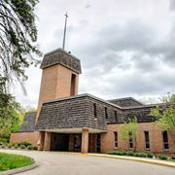  Featured discussion: "How to Attract New Members”
Southwest District – Oct. 4  Win Schuler’s Restaurant  115 S. Eagle Street, Marshall, Mi  10:00 am meeting  Guest Speaker: Bea Wassenberg, MFMC President  All lunches are $20.00, including 20% gratuity  Meal order is placed on meeting day.  Send no money prior to the meeting.  Contact Rochelle Daneluk, SWD President  with any questions.  rocdnlk@aol.com  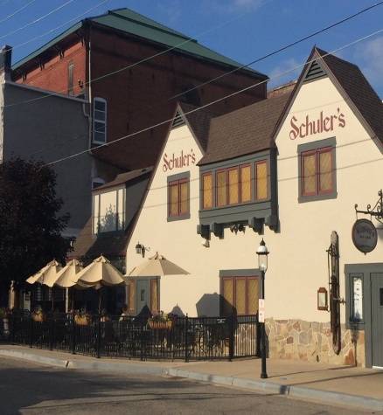  Host Club: Jackson Tuesday Musicale | 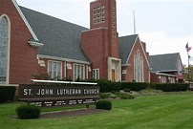  Southeast District - Oct. 11  St John Lutheran Church  23225 Gill Road, Farmington Hills MI 48335  Registration: 9:30 am  Meeting: 10:00 am  Continental Breakfast - $12.00  checks due 10-01-2019  Payable to: The Farmington Musicale  memo: SE District  Send to: Brian Golden, Treasurer  PO Box 551  Farmington MI 48332-0551  248-701-8112  bgolden@pastways.info  Host Club: The Farmington Musicale
page 4………………………………………………………………………………………………………………………………………………..Fall, 2019

The Music of Language and the Language of Music

What is poetry and what is music? Definitions for these terms give us clues as to why the two blend together so well:

Poetry- the art of traditional rhythmical composition, written or spoken, for exciting pleasure by beautiful, imaginative, or elevated thoughts

Music - an art of sound in time that expresses ideas and emotions in significant forms through the elements of rhythm, melody, harmony, and color

Both definitions emphasize portraying emotion as an important quality. Music depicts emotion in lyrics, instrumentation and performance. Emotion in poetry is shown by the words, their construction and the cadence of the speaker.

In February, The Birmingham Musicale was treated to “The Pianist and the Professor”, a combination of music and poetry presented by Barbara Woolf and Dr. Edward Sharples. Originally asked to present a fund-raiser for their church, the duo decided to combine their skills to create a unique program. Their February performance concentrated on African American poetry and music, presenting the progression of black history through spirituals and poetry into more contemporary works for the piano.

Barbara, a former President of The Birmingham Musicale, majored in piano performance, performs as a soloist and maintains a private studio. Dr. Sharples earned a Ph.D. in English Language and Literature and served in many positions at Wayne State University in Detroit.

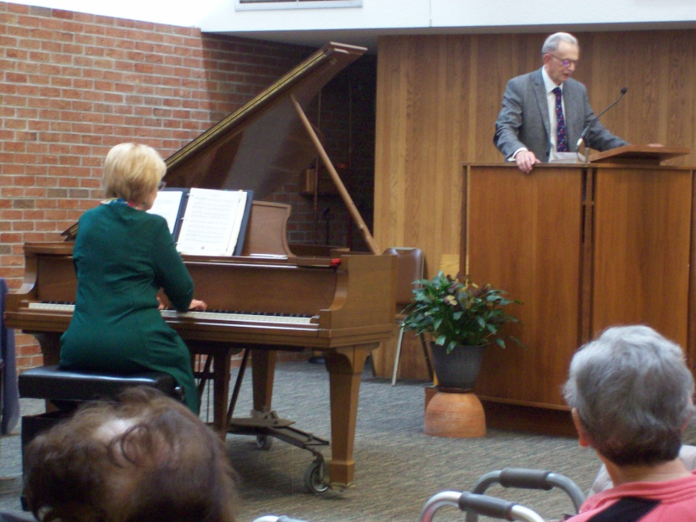The duo has presented several different programs in the area as they explore the music of language and the language of music.
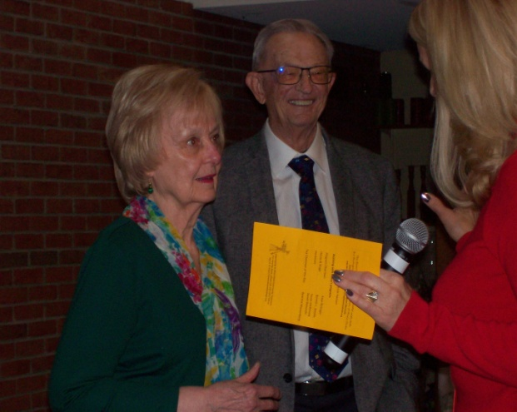

page 5……………………………………………………..…………………………………………………………………………………………..Fall, 2019

Show your Federation pride!

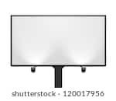

Place an advertisement in the
2020 Convention program:

Back Cover - $250
Inside Covers - $200
Full Page - $150 Half Page - $100
Quarter page (2.25x3.5) - $75
Quarter Page (4.85x1.625) - $75

Contact: Mary Jane Timmer k.timmer@sbcglobal.net
3635 Leonard St., NW
Grand Rapids, MI 49534

Page 6………………………………………………………………………………………………………………………………………..………..Fall, 2019

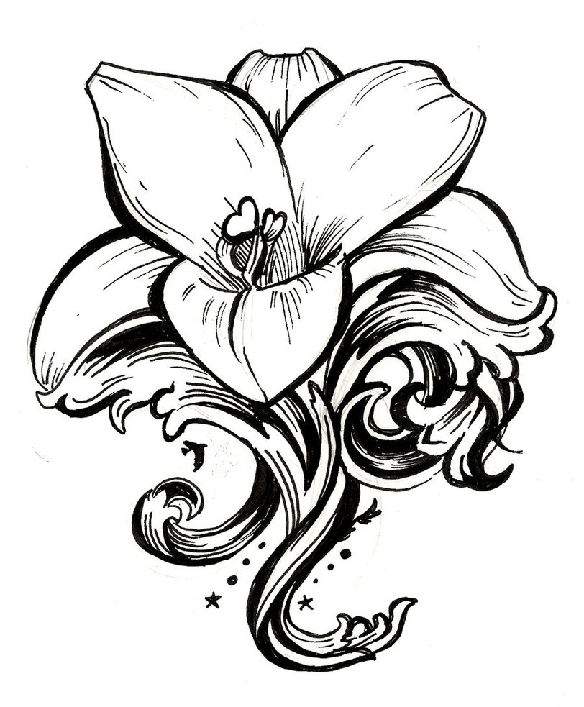
In Memoriam:

We are sad to announce the passing of longtime Battle Creek Morning Musical Club member Frances Isaac. She was twice-President of the club, sang in the chorus and served as Junior Festival Chairperson. Frances credited her enjoyment of music and staying active for her longevity. “Get involved in community activities,” she advised. “Don’t just sit at home.

Frances Isaac 2/17/18 – 1/21/19
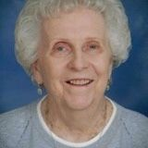 Mary Lou Lourim
10/15/31 – 5/24/19
Mary Lou Lourim, 43-year member of Jackson Tuesday Musicale, died in May, 2019. She served as Chairman of the Music Awards Committee, sang in the Chorus and was an Honorary Past President. Mary Lou was also a former MFMC Chaplain. She loved making music, played both piano and organ, and was a church choir member for 40 years. In fact, she was with the choir when they sang at both Carnegie Hall and Lincoln Center.

